**Belarus Production and Trade Concern of the timber, woodworking and pulp and paper industry "BELLESBUMPROM"**

**RUE "Zavodgazetnoybumagi"**

**Shklov, st. 1st Factory, 9**

**tel./fax +3752239-71-843, mob. +37529- 352-25-20**

**www.domostroenie.by**

**COMMERCIAL OFFER**

**OF THE BRANCH «DOMOSTROENIE»**

Our modern enterprise, founded on basis of RUE «Zavodgazetnoybumagi» on 23rd of January 2009, using the newest technologies and equipment of leading European producers, such as «Homag», «Cathild», «Ledinek», «Hundegger» for production of molded products, glued laminated beam, frame-panel houses and glued laminated beam houses, pellets, responding to requirements and expectations of consumers, offers you cooperation:

**OUR PRODUCTION**

1. Frame-panel houses [HTS codes 4418908000]

(GOST 1074-97STB 1722-2007, TU BY 790282162.001-2010): capacity of series production – 2000 square meters per month. Full set of the house includes all that is necessary for its montage: set of mounted walls and overlaps, window and door blocks, interior and exterior sheathing, floor board, rafter system, full set of hardware. Usage of modern heat-insulation materials allows to provide resistance of enclosing constructions not less than 6,11 m² °C/W.

1. Glued laminated beam houses [HTS codes 4418901000]

(ТU BY 790282162.004-2010, EN 14080):сapacity of series production – 5-8 sets of glued laminated beam houses per month. While gluing of softwood lamellas, our enterprise uses certified glue AKZONOBEL, which got an approval of Norwegian, French and German institutes for production of bearing wooden constructions.

1. Glued laminated beam [HTS codes 4418901000]

– selective timber of softwood, which is being cut, treated in drying cameras with soft regimes to relative humidity from 8 to 12%. Dried commodity is being planed from 4 sides to get precise sizes, sorted and glued on powerful hydraulic press to glued laminated beam of different sections.

* Capacity of series production per year – 15 000 м³ multilayered glued beam;
* Planed beam [50*600*75-200 (h) mm; 50*350*200-300 (h) mm; 50-300*200- 600 (h) mm];
* Profiled beam [80-300*100-250(h) mm];
* Maximum length of beam – 18 m.
* **Price of glued laminated beam:**

|  |  |  |
| --- | --- | --- |
| Name | Unit of measurement | Price in €  (without VAT) |
| Single layer beam 50*190/45*150/45*100 | м³ | 360 |
| Squared beam | м³ | 420 |
| Profiled beam | м³ | 440 |
| Wall beam | м³ | 460 |

*Price is formed on FCA conditions

**SALE AND DELIVERY CONDITIONS**

- frame-panel houses and glued laminated beam houses: delivery conditions – FCA; terms of payment – full prepayment, partial prepayment; price of frame-panel houses is formed depending on price of spent materials, glued laminated beam houses – depending on quantity of beam cubes, used for production.

* glued laminated beam: packaging – packets in the film; delivery conditions – FCA;

payment conditions – full prepayment.

**СOOPERATION EXPERIENCE**

RUE «Zavod gazetnoy bumagi» branch «Domostroenie» cooperates with different companies near and far abroad. We have experience of work with such countries as Russia, Italy, Latvia, Azerbaijan, France and etc.

**We would be glad to cooperate with you!**

**Contacts of sales department:**

Tel./fax: + 375-2239-71-843

Tel.: + 375-29-352-25-20

E-mail: [ptozgb@](mailto:ptozgb@)domostroenie.by

[www.domostroenie.by](http://www.domostroenie.by)

**We offer houses project:**

**1 Frame-panelhouse*“VERNY SECOND”***

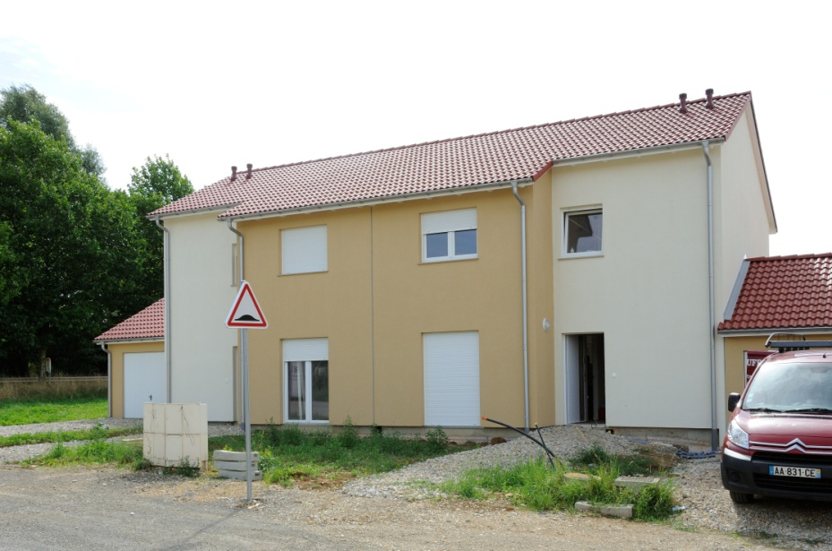

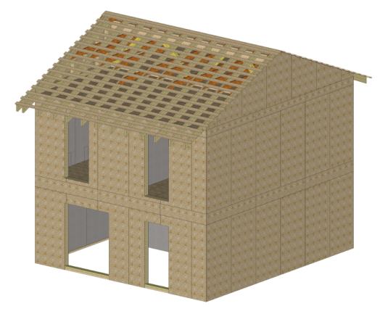

**Price FCA: 19 345 EUR (without VAT)**

**Area –92,31m2.**

**Homekit :**set of panels panels for walls, overlaps,

frontons, additional elements (truss system,

heat-insulating slab of slagwool , OSB, waterproofing

of the roof and walls, vapor barrier film, gypsum board),

set of metalware for the assembly of wall panels,

partitions.

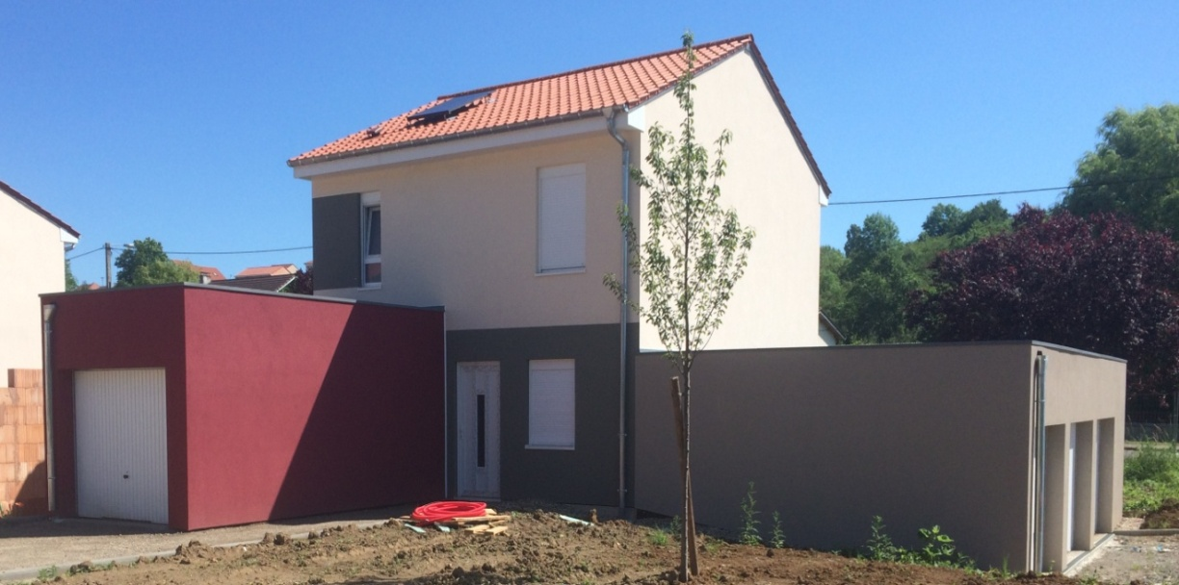

**2Frame-panelhouse *HAUCOURT MOULAINE***

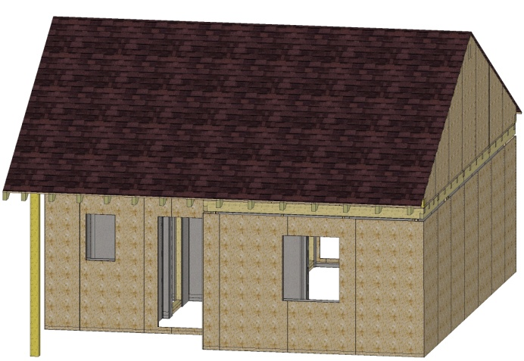

**Price FCA: 9 850 EUR (without VAT)**

**Area –48,79 m2.**

**Homekit:**set of panels panels for walls, overlaps,

frontons, additional elements (truss system,

heat-insulating slab of slagwool , OSB, waterproofing

of the roof and walls, vapor barrier film, gypsum board),

set of metalware for the assembly of wall panels,

partitions.

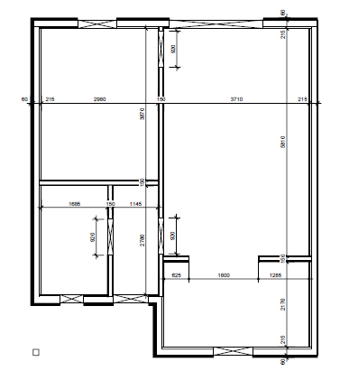

**Frame-panelhouse*VILLERUPT (8,3x6,3)*** 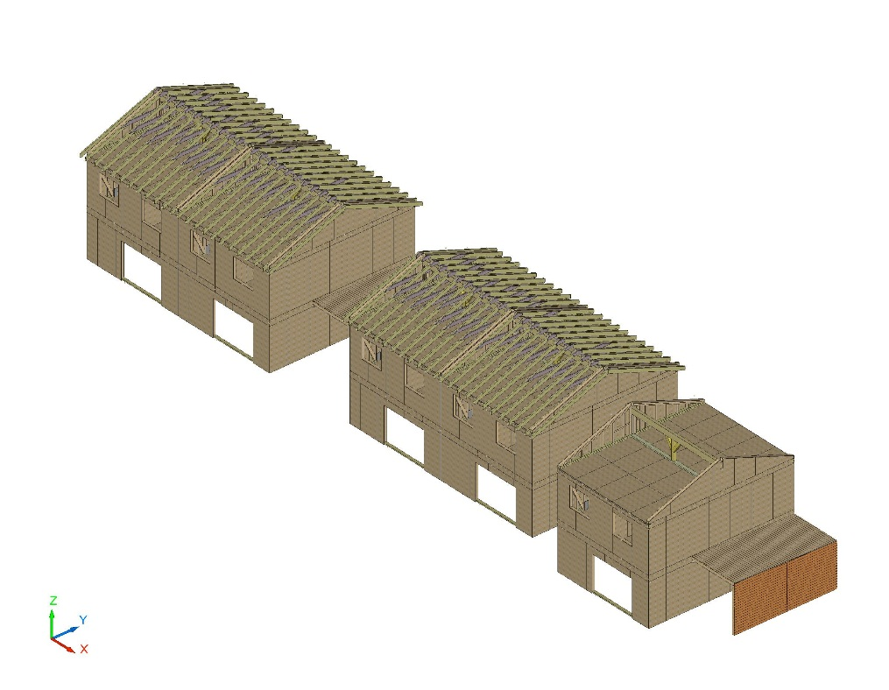

**Price FCA: 17 150 EUR**

**(without VAT)**

**Area –88 m2. 1st floor**

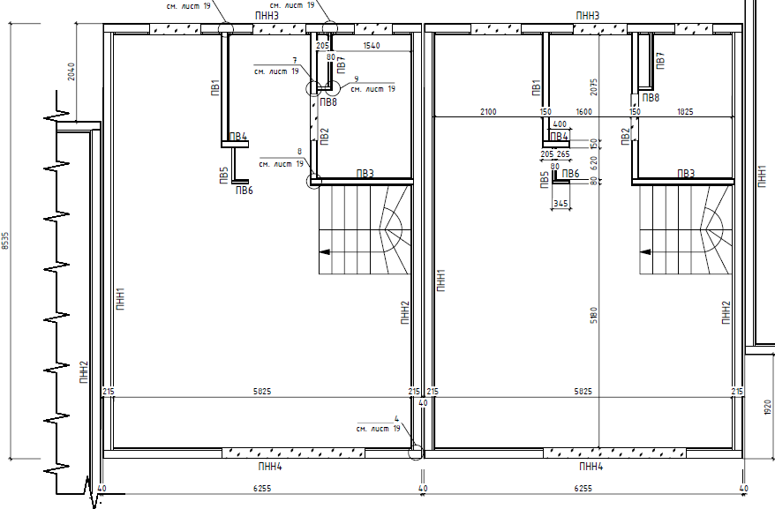

**Homekit:**set of panels panels for walls, overlaps,

frontons, additional elements (truss system,

heat-insulating slab of slagwool , OSB, waterproofing

of the roof and walls, vapor barrier film, gypsum board),

set of metalware for the assembly of wall panels,

partitions.

.

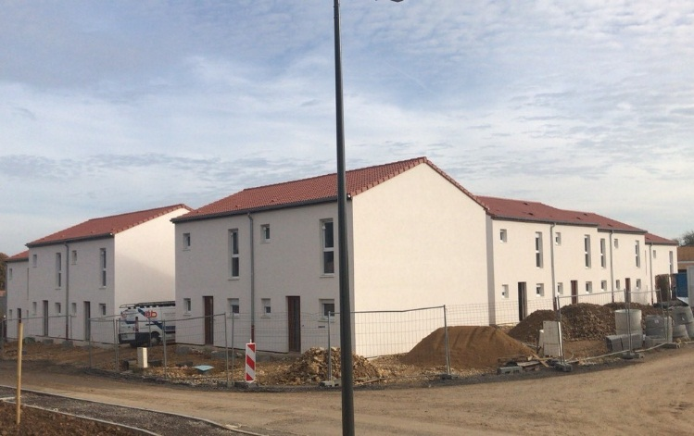

**2nd floor**

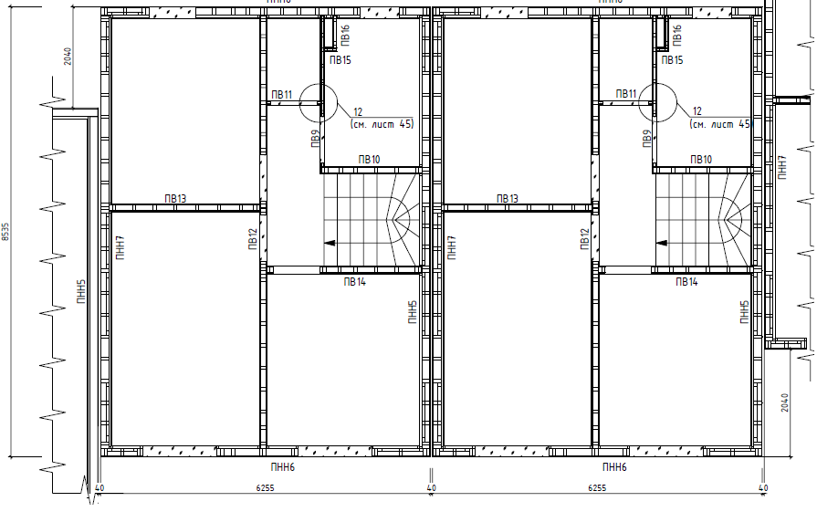

**Contacts of sales department:**

Tel./fax: + 375-2239-71-843

Tel.: + 375-29-352-25-20

E-mail: [ptozgb@](mailto:ptozgb@)domostroenie.by



|  |  |  |  |  |  |
| --- | --- | --- | --- | --- | --- |
| **№** | **Name of the project** | **Totalarea, m2** | **Price without VAT, EUR (FCA)** | **Homekit** | **Generalview** |
| **1** | **Frame-panelhouse "ALEXANDRIA"**  **(11,85х9,8)** | **90,20** | **32 000** | set of panels , truss system,outer sheathing block-house,trim, floor board-27,wood casement windows, wooden interior doors  *Square-edged plank of sort 1-3* | **Вид 5.jpg** |
| **2** | **Frame-panelhouse "RADUGA"**  **(11,5х9,35)** | **171,76** | **34 500** | set of panels, truss system, a set of of nails floor boards-27  drywall, wall paneling, wind farm board  *Square-edged plank of sort 1-3* | **Вид 2.jpg** |
| **3** | **Glued laminated beam house**  **«ALEXANDR»**  **(9,8х6,75)** | **113,00** | **29 900** | Timber wall 140mm*210mm, rafter, trimmer joists, beams, planed board, timber of the siege (sort B), waling, rack  *Square-edged plank of sort 1-3* | **C:\Documents and Settings\Marina.Rudkovskaya\Local Settings\Temporary Internet Files\Content.Word\Новый рисунок (17).bmp** |
| **4** | **Glued laminated beam house**  **«ALESYA»**  **(8,0х6,0)** | **48,50** | **22 000** | Timber wall 140mm*210mm, rafter, trimmer joists, beams 190*50, planed board, timber of the siege (sort B), waling, rack  *Square-edged plank of sort 1-3* | **C:\Documents and Settings\Marina.Rudkovskaya\Local Settings\Temporary Internet Files\Content.Word\Новый рисунок (18).bmp** |
| **5** | **Glued laminated beam house**  **«BEREZINO»**  **(12,0х9,2)** | **194,00** | **46 300** | Timber wall , timber wall (interior) 140mm*140mm, rafter, trimmer joists, beams, planed board, timber of the siege(sort B), waling, rack  *Square-edged plank of sort 1-3* | **C:\Documents and Settings\Marina.Rudkovskaya\Local Settings\Temporary Internet Files\Content.Word\Новый рисунок (19).bmp** |
| **6** | **Glued laminated beam house**  **«VIKING»**  **(9,0x7,8)** | **62,83** | **18 800** | Timber wall 140mm*210mm, rafter, trimmer joists, beams, planed board, timber of the siege (sort B), waling, rack  *Square-edged plank of sort 1-3* | **C:\Documents and Settings\Marina.Rudkovskaya\Local Settings\Temporary Internet Files\Content.Word\Новый рисунок (20).bmp** |
| **7** | **Glued laminated beam house**  **«LIDA»**  **(13,0х11,0)** | **140,00** | **44 800** | Timber wall 140*210 , timber wall (interior) 140mm*110mm, rafter, trimmer joists, beams, planed board, timber of the siege(sort B), waling, rack  *Square-edged plank of sort 1-3* | C:\Documents and Settings\Marina.Rudkovskaya\Local Settings\Temporary Internet Files\Content.Word\Новый рисунок (21).bmp |
| **8** | **Glued laminated beam house**  **«MARA»**  **(11,3х7,3)** | **133,5** | **29 400** | Timber wall , timber wall (interior) 140mm*140mm, rafter, trimmer joists, beams, planed board, timber of the siege (sort B), waling, rack  *Square-edged plank of sort 1-3* | C:\Documents and Settings\Marina.Rudkovskaya\Local Settings\Temporary Internet Files\Content.Word\Новый рисунок (22).bmp |
| **9** | **Glued laminated beam house**  **«SOKOL»**  **(8,0х6,0)** | **47,5** | **18 280** | Timber wall 140mm*80mm, rafter, trimmer joists, beams, planed board, timber of the siege(sort B), waling, rack  *Square-edged plank of sort 1-3* | C:\Documents and Settings\Marina.Rudkovskaya\Local Settings\Temporary Internet Files\Content.Word\Новый рисунок (24).bmp |
| **10** | **Glued laminated beam house**  **«SVETLANA»**  **(13.7x12.5)** | **159,99** | **60 800** | Timber wall 140 * 210 mm, timber wall 129 * 210 mm, timber wall 59 * 210, rafter, trimmer joists, beams 50 * 210 mm, planed board 150 * 45mm, 210 * 40 mm, timber of the siege 210 * 80 mm, waling 60 * 100mm, rack 200 * 200 mm  *Square-edged plank of sort 1-3* | **Вид 17.jpg** |
| *\*\*\*\*****The foundation and construction works in the cost of these projects is not included.*** | | | | | |

**Contacts of sales department:**

Tel/fax: + 375-2239-71 843

Tel.: + 375-29-352-25-20

E-mail: ptozgb@domostroenie.by

[www.domostroenie.by](http://www.domostroenie.by)

**SUMMER HAUSE**

|  |  |  |  |  |
| --- | --- | --- | --- | --- |
| **№** | **Name of the project** | **Totalarea, m2** | **Price without VAT, EUR (FCA)** | **Generalview** |
| **1** | **МАФ-1.12**  **(2500*3000)** | **7,5** | **620** | X:\Рудковская\могилевская типография\беседки\МАФ-1-12.jpg |
| **2** | **МАФ-2.12**  **(4000*5000)** | **20** | **1 530** | **X:\Рудковская\могилевская типография\беседки\МАФ 2.12.jpg** |
| **3** | **МАФ-5.12**  **(4000*8500)** | **34** | **1 900** | X:\Рудковская\могилевская типография\беседки\МАФ 5.12.jpg |
| **4** | **МАФ-6.12**  **(4000*8500)** | **34** | **2 470** | **X:\Рудковская\могилевская типография\беседки\МАФ 6.12.jpg** |
| **5** | **МАФ-7.12**  **(3000*4000)** | **12** | **870** | X:\Рудковская\могилевская типография\беседки\МАФ 7.12.jpg |
| **5** | **МАФ-8.12**  **(6000*3000)** | **18** | **1 290** | X:\Рудковская\могилевская типография\беседки\МАФ 8.12.jpg |
| *\*\*\*\*****The foundation and construction works in the cost of these projects is not included.*** | | | | |

**GARDEN HOUSE**

|  |  |  |  |  |
| --- | --- | --- | --- | --- |
| **№** | **Name of the project** | **Totalarea,**  **m2** | **Price without VAT, EUR (FCA)** | **Generalview** |
| **1** | **Glued laminated beam house«Alesya»** | **22,9** | **4 100** | **C:\Documents and Settings\Marina.Rudkovskaya\Local Settings\Temporary Internet Files\Content.Word\Новый рисунок.png** |
| **2** | **Glued laminated beam house«DD-Briz-80»** | **39** | **5 360** | **X:\Алеся\Дома\бриз\бриз\Аксонометрия 1.jpg** |
| **3** | **Glued laminated beam house«Katerina»** | **16,6** | **1 620** | **C:\Documents and Settings\Marina.Rudkovskaya\Local Settings\Temporary Internet Files\Content.Word\Новый рисунок (1).png** |
| **4** | **Glued laminated beam house«Polina»** | **14,7** | **1 160** | **ЛД-Полина.3d (1).PNG** |
| **5** | **Glued laminated beam house«LD-Elena-1-01»** | **10,41** | **990** | **X:\!!!1Миша\проекты\борисов\govard.jpg** |
| *\*\*\*\*****The foundation and construction works in the cost of these projects is not included.*** | | | | |

**Contacts of sales department:**

Tel./fax: + 375-2239-71 843

Tel.: + 375-29-352-25-20

E-mail: ptozgb@domostroenie.by

[www.domostroenie.by](http://www.domostroenie.by)